

A REPORT on “One Day Workshop on Startup Awareness”
ELECTRICAL ENGINEERING DEPARTMENT

“One day Workshop on Startup Awareness” under SSIP was organized by Electrical Engineering Department on 05/02/2018. Total 100 students have attended the 2 sessions. In which 2 Experts Mr. Miraj Doshi in morning session and Prof. Vicky B. Doshi in evening session have shared their startup and entrepreneur journey with students. Student of 4th and 6th Sem was motivated and their queries about Startup and path to become an entrepreneur was discussed.
Glimpses:
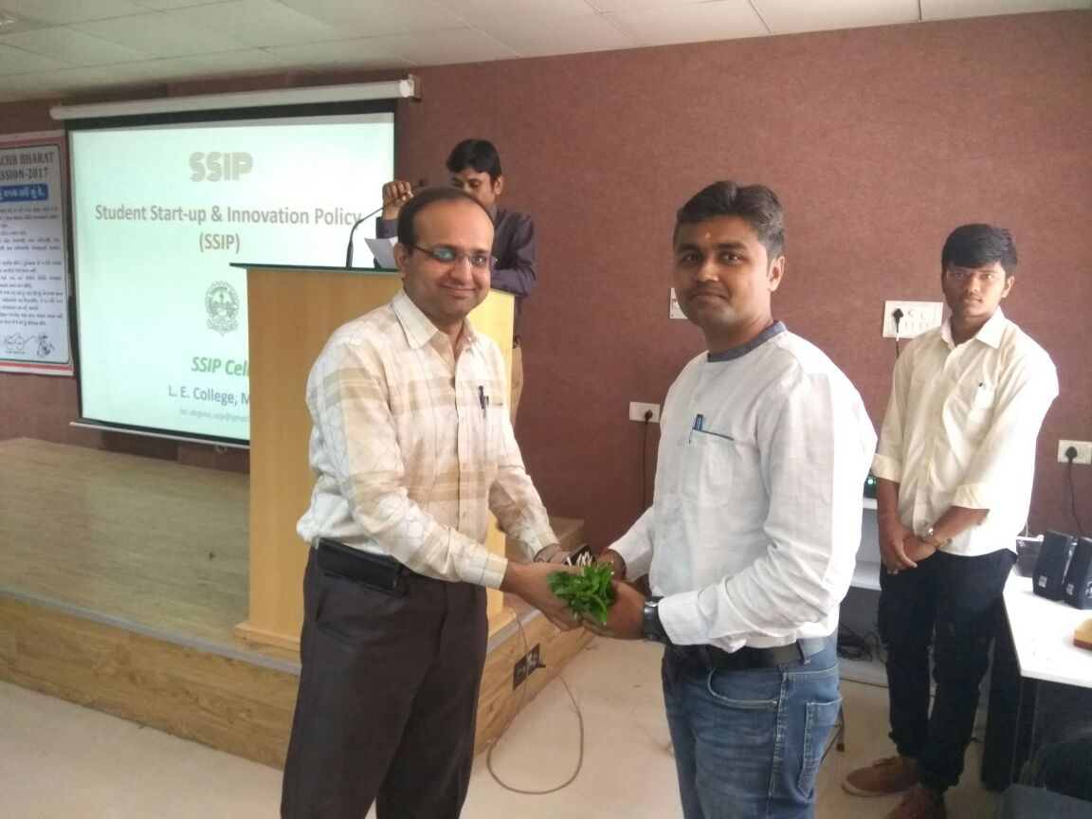  Welcome of expert by Bookey to Mr.Miraj Doshi by Prof. B.Y.Vyas. | 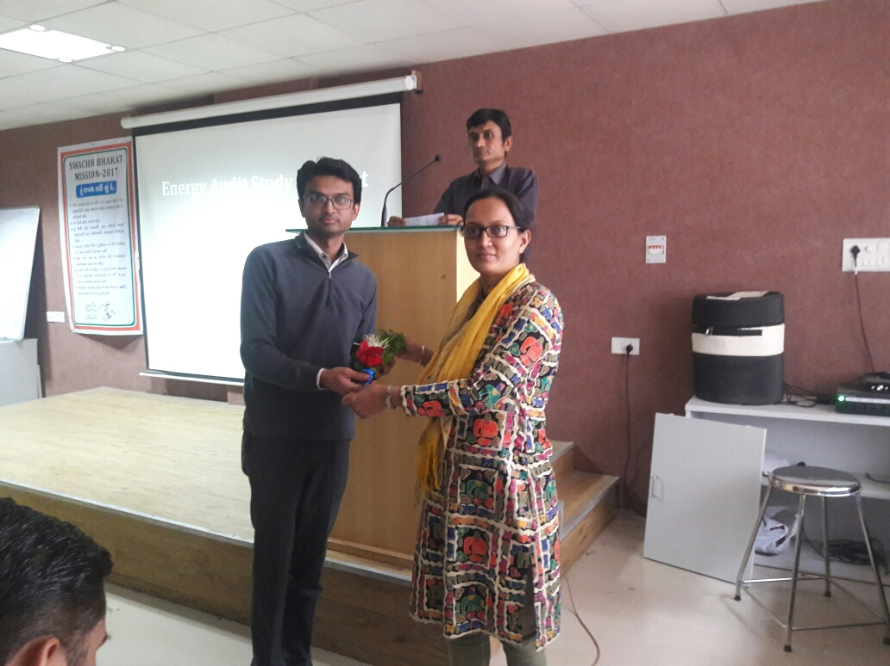  Welcome of expert by Bookey to Prof. Vicky B.Doshi by Prof.B.B.Parmar.
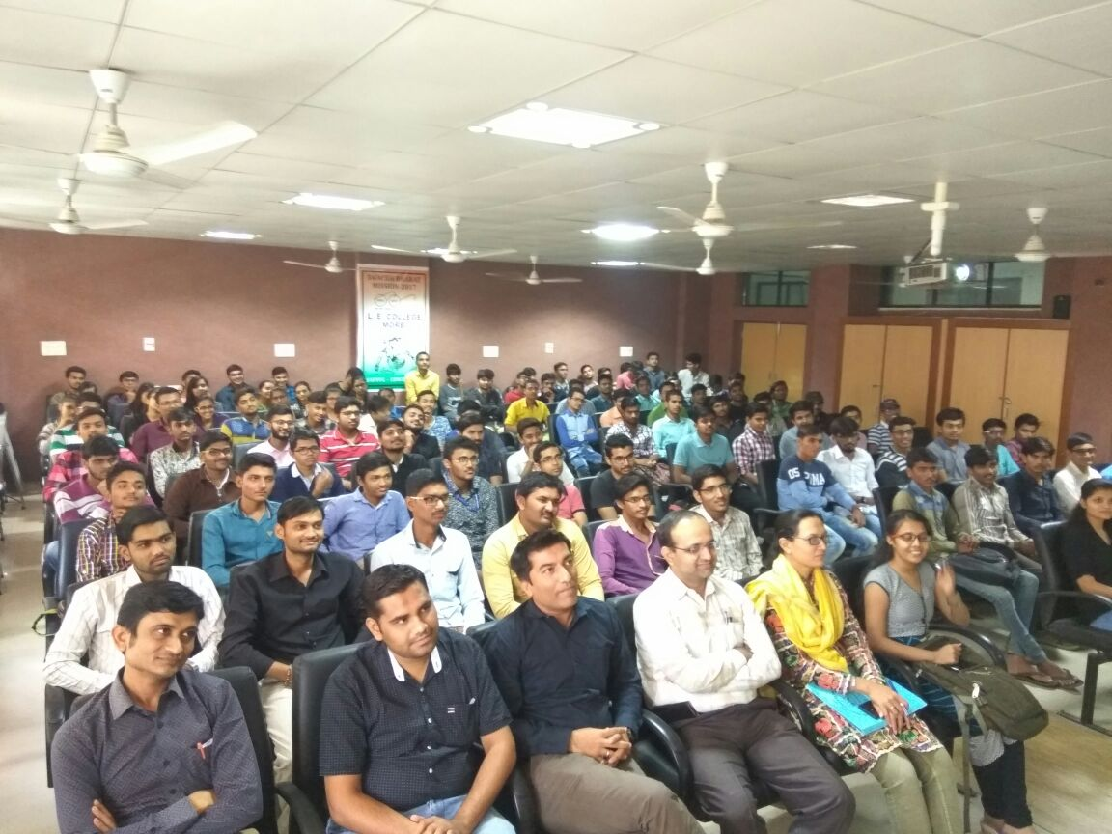  Department students and staff benifited from expertize | 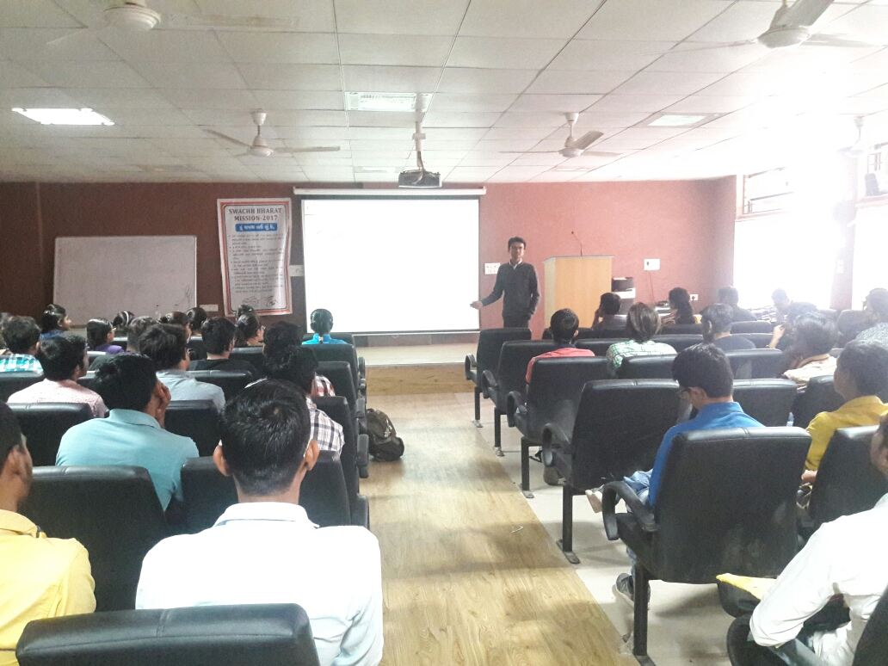  Prof. Vicky Doshi sharing his views with students

Activity/Event Coordinator (Name & sign) HOD (Sign & Stamp)
Prof. Vishal G. Jotangiya (Electrical)
Prof. Hitesh M. Karkar (Electrical)

