

A REPORT on “Utility Patent filed on Auto Razor”
Mechanical Engineering Department Datd.: 15 May 2019

Financial Year: 2019-20
Title of Innovation: Auto Razor
Type of Patent: Utility Patent
Field Of Innovation: Personal and healthcare
Abstract:
The main purpose of this innovation is to present the innovative design and utility product like ‘Auto Razor’, which is an idea to make shaving razor with inside foam capability and refillable also. The basic issue identified is with the daily shavers like businessman, army man and police. They are keeping shaving items like blade, foam, etc. separately, which becomes hard to use with. The concept is to design and develop a razor with inside foam and can be refillable. The product would be proved a beneficiary thing to the user and business application.
Team Members Name/Innovators: Ankit Shukla Prof. M. B. Vaghela Manish Vaghela.
Name of Guide: Prof. M. B. Vaghela
Patent Application No: 201921019285
Patent Filed Application Date 15-05-2019
SSIP Fund Used: Rs. 25000.00
Glimpses:
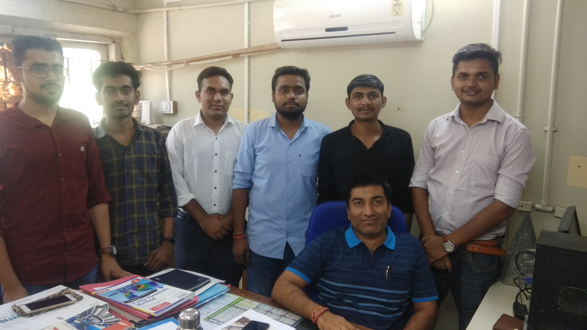
Prof. M. B. Vaghela with students of Mechanical Engineering department

